**NAME- AMAN KUMAR**

**COURSE- B.VOC SOFTWARE DEVELOPMENT**

**ROLL NO- 20232703**

**SUBJECT- FULLSTACK**

**1. Show/Hide and Toggle Effects**

* Implement show(), hide(), and toggle() functions with buttons.
* Use .click() to trigger events that manipulate element visibility.
* Add animation effects like slideUp() and slideDown().

Code:-

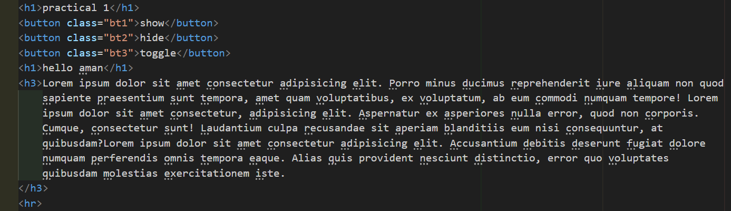

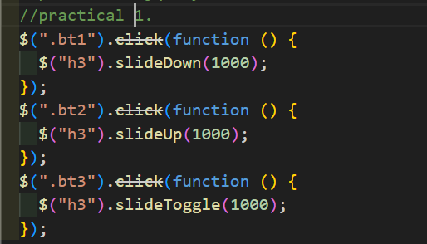

Output:-

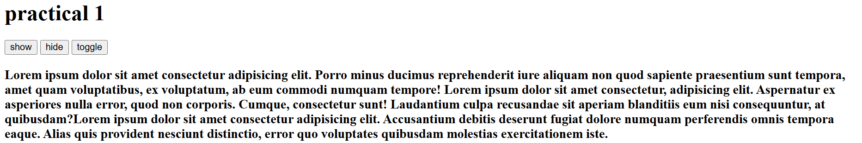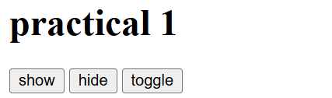

**2. Drag and Drop Functionality**

* Create a draggable and droppable UI.
* Provide visual feedback when items are dragged or dropped.

Code:-

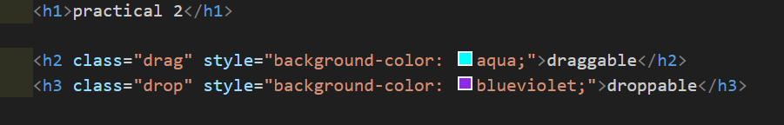

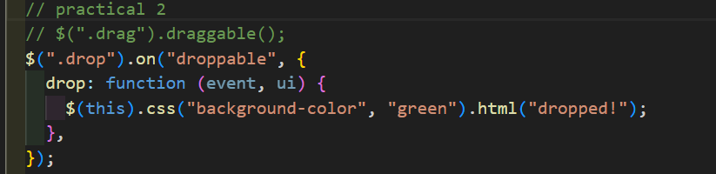

Output:-

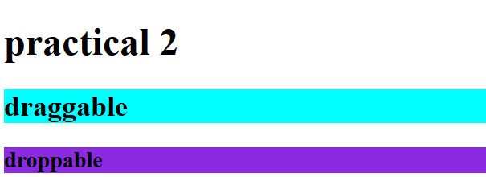

**3. Image Slider using jQuery**

* Use .fadeIn() and .fadeOut() actions for smooth transitions.
* Control slides with buttons using selectors and click() action.
* Implement auto-play functionality using setInterval().

**Code:-**

x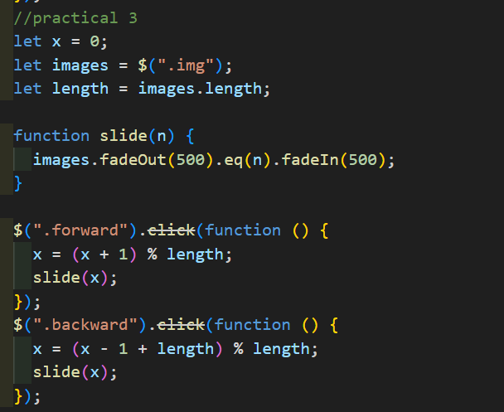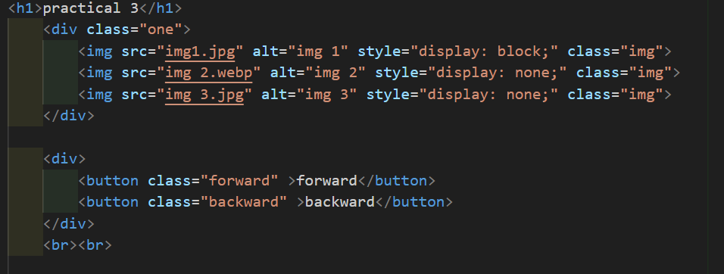

Output:-

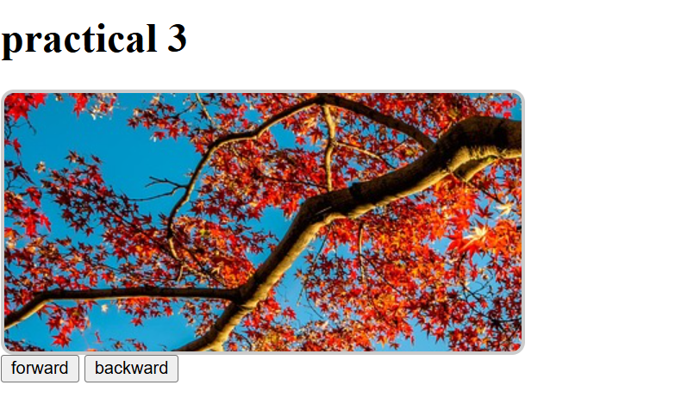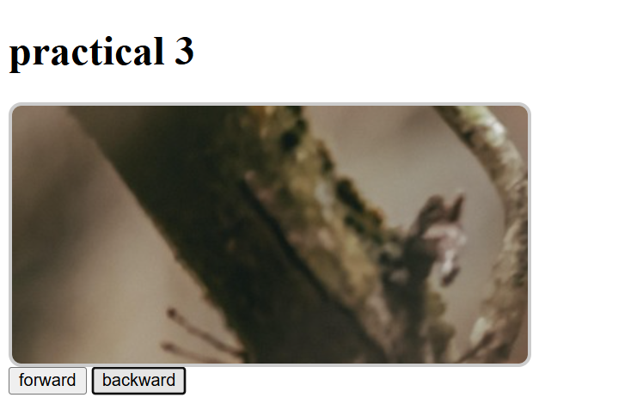

**4. AJAX Call with jQuery**

* Use jQuery AJAX to fetch data from a REST API.
* Display fetched data dynamically.

**Code:-**

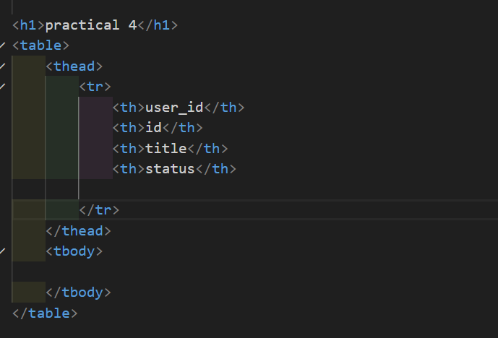

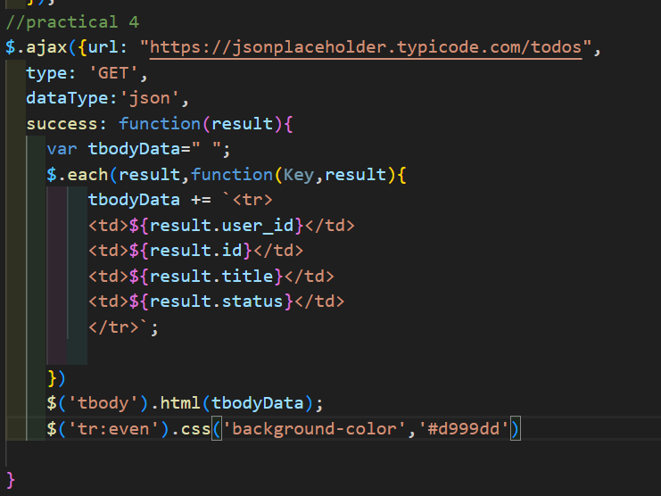

Output:

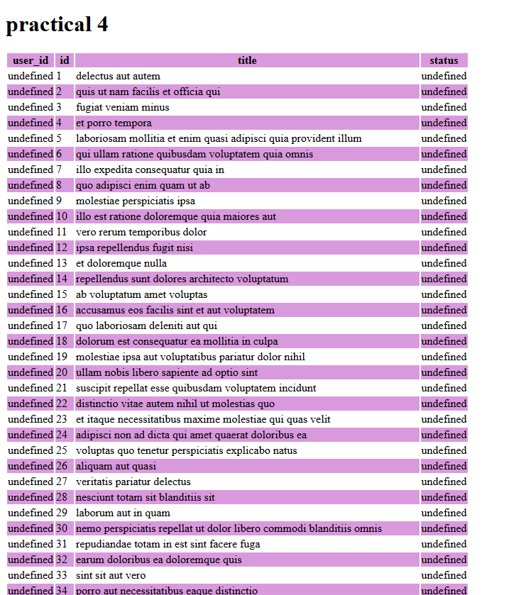

**5. Form Validation using jQuery**

* Use jQuery selectors to target input fields and validate them.
* Apply actions like .val(), .css(), .text(), and .html() to show/hide error messages
* dynamically.
* Validate fields like name, email, and phone number

**Code:-**

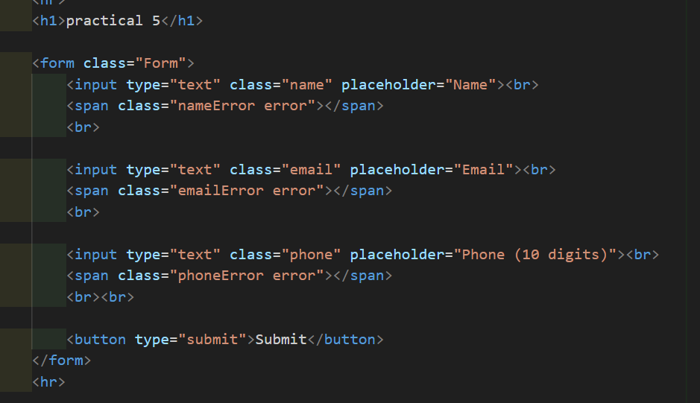

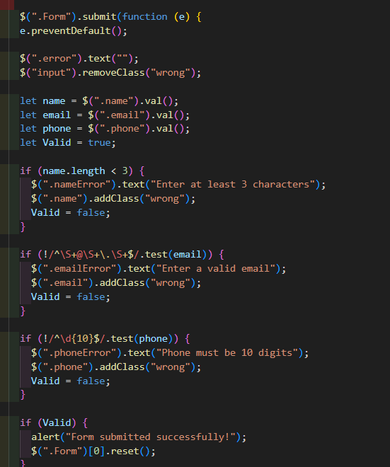

**Output:-**

